Lab 02 – Crystal Structure and Text Editing

**1. Symmetry in Materials.** Two-dimensional and three-dimensional crystals exhibit a number of symmetry elements, which map atoms on to each other within in a unit cell and also make them periodic in space.

(a) For the two-dimensional unit cell depicted below, write the chemical formula of the material.

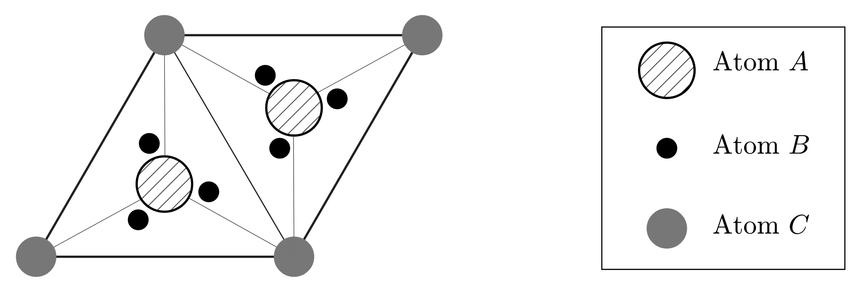

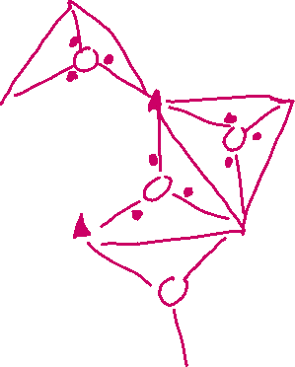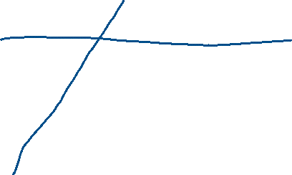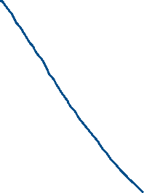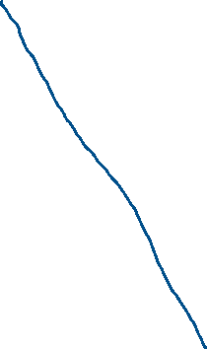

(b) Identify the rotation axes at the different atomic sites.



(c) Sketch all mirror planes in the structure (You may draw on the sketch above if you like.)

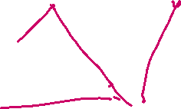

**2. Structures of fcc-derived Crystals.** This question explores the geometric tiling of various structures obtained from a combination of one or more fcc lattices. The table on the next page shows two-dimensional (2D) slices of the atomic positions (rows) for many of the three-dimensional derivative structures (columns) along the z-direction of the crystal.

(a) For each structure with an empty 2D slice containing a lowercase Roman numeral, sketch the complete slice by adding the necessary atoms in that layer. Slices that have been grayed out do not require additional atoms.

(b) For each material in the table, provide the stoichiometry (chemical formula).

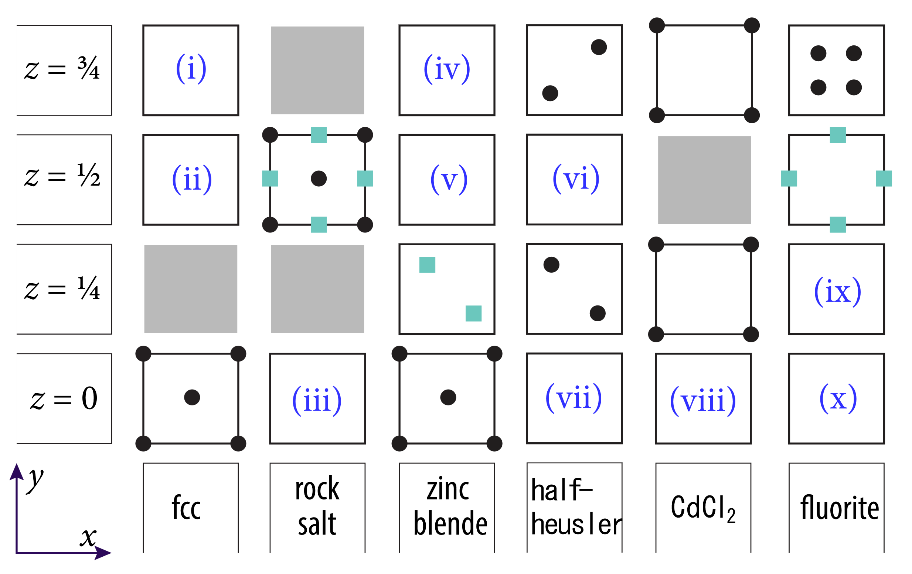

**3. Generating and Editing Crystal Structures.** On Moodle you will find a file for today called “POSCAR”. (a) Open the POSCAR with Vi and use it as a template to create a new crystal structure with the following properties:

* Orthorhombic
* Chemical Formula A2B2C
* At least one mirror plane
* At least one rotational axis

When finished, save and upload your new file (which you should rename “POSCAR_<yourname>”) to Moodle.

(b) Thus far, our unit cell lattice parameters have always been at right angles. How would we specify a trigonal unit cell?